PROJECT DEVELOPMENT PHASE

SPRINT - 3

|  |  |
| --- | --- |
| DATE | 12 NOVEMBER 2022 |
| TEAM ID | PNT2022TMID11845 |
| PROJECT NAME | SMART FASHION RECOMMENDER APPLICATION |

CART PAGE :

|  |
| --- |
| <section class="container mt-3 pt-3 pt-md-4"> |
| <div class="row"> |
| <div class="col-12 col-md-6"> |
| <div class="shadow p-2 mt-3" *ngFor="let t of [1,1,1,1,1]"> |
| <div class="d-flex align-items-center">  <img src="/assets/products/2.jpg" alt="Product |
| image" class="product-img" /> |
| <p class="fw-bold ms-2">Title of the image</p> |
| </div> |
| <p>Price : {{344 | currency:'INR'}}</p> |
| </div> |
| </div>  <div class="col-12 col-md-6"> |
| <h3>Total Cart Details</h3> |
| <hr> |
| <div> |
| <p>Total items : {{5}}</p> |
| <p *ngFor="let t of [1,1,1,1,1], index as i">Item : {{i |
| + 1}} = {{63 | currency:'INR'}}</p>  <p>TOTAL PRICE : {{5464 | currency:"INR"}}</p> |
| <hr> |
| <div class="col-12 col-md-6"> |
| <button class="primary-btn mt-2 w-100">PROCEDURE TO |
| BUY</button> |
| </div> |
| </div>  </div> |
| </div> |
| </section> |
|  |

CART CSS:

|  |
| --- |
| .product-img { |
| width: 4rem; |
| height: 4.5rem; |
| } |

# OUTPUT SCREEN

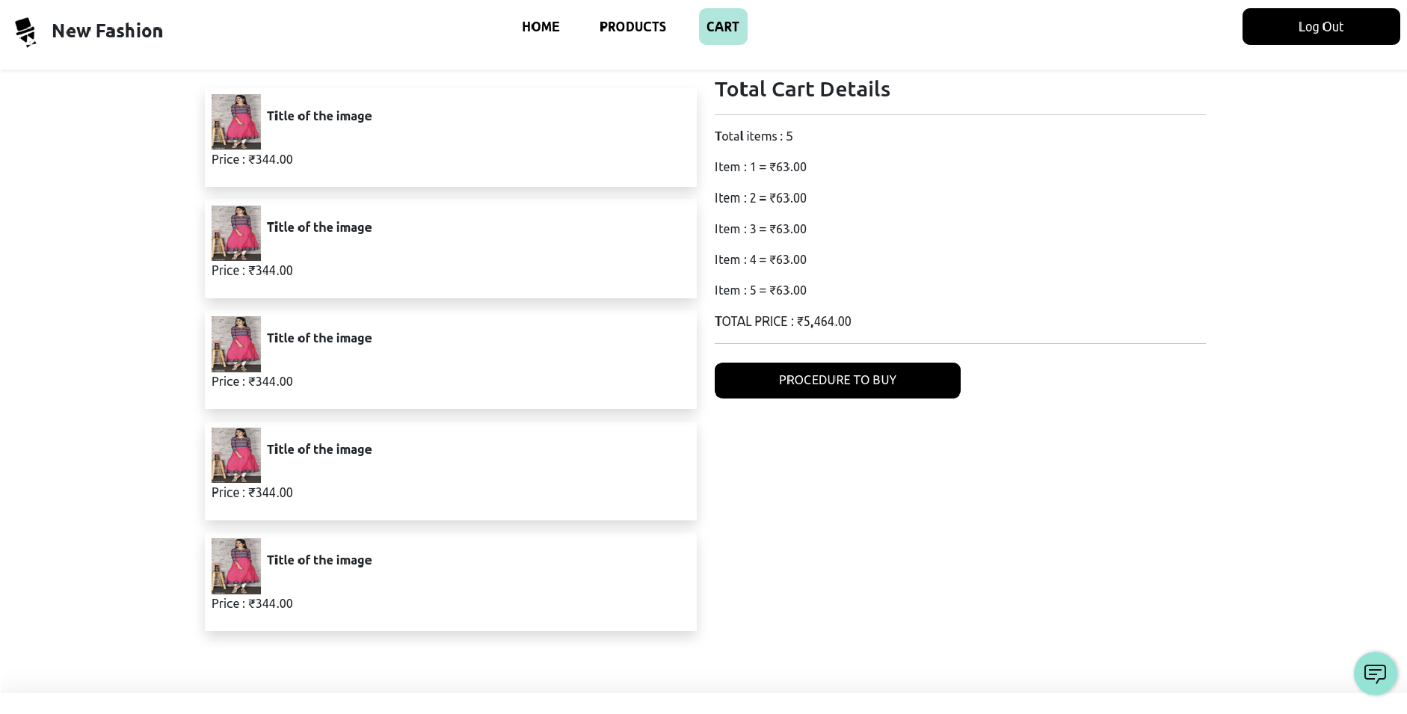

VIEW PRODUCT PAGE HTML

|  |
| --- |
| <section class="container-fluid pt-3 pt-md-4"> |
| <div class="row justify-content-around"> |
| <div class="col-12 col-md-6 col-lg-4"> |
| <img src="/assets/products/1.jpg" alt="product image" |
| class="w-100"> |
| </div>  <div class="col-12 col-md-6 col-lg-4"> |
| <h2>New product</h2> |
| <p class="text-muted"> |
| Women Beige Floral Yoke Design Straight Kurta with |
| Trousers & With Dupatta |
| </p> |
| <div class="d-flex align-items-center">  <div class="d-flex align-items-center bg-success |
| text-white fw-bold px-2 rounded"> |
| <span> |
| {{'4.0'}} |
| </span> |
| <span class="material-symbols-outlined text-white |
| ms-2 fs-6"> |

|  |
| --- |
| star |
| </span> |
| </div> |
| <div class="title-text ms-1" style="font-size: 14px;">  {{'333'}} Reviews |
| </div> |
| </div> |
| <hr> |
| <!-- pricedetails --> |
| <div> |
| <p class="mb-0 fw-bold fs-3">{{'234' | currency:  'INR'}}</p> |
| <span class="text-success">inclusive of all taxes</span> |
| </div> |
| <!-- address details --> |
| <div class="mt-2"> |
| <h5>ADDRESS : </h5> |
| <p class="mb-0">No:1/2 , NEW TEAM, near chennai</p>  <p class="mb-0">panimalar</p> |
| <p class="mb-0">poonamallee</p> |
| <p class="mb-0">chennai 602026</p> |
| <p class="text-end text-success cursor-pointer"><a |
| [routerLink]="">Change Address > </a></p> |
| </div> |
| <hr>  <!-- button section --> |
| <div class="row mt-3"> |
| <div class="col-12 col-md-6"> |
| <button class="primary-btn mt-2 text-dark w-100" |
| style="background-color: var(--primary-color);">ADD |
| TO CART</button> |
| </div>  <div class="col-12 col-md-6"> |
| <button class="secondary-btn mt-2 w-100">BUY |
| NOW</button> |
| </div> |
| </div> |
| </div> |
| </div>  </section> |

VIEW PRODUCT LOGIC

|  |
| --- |
| // get details |
|  |
| async getProductDetails(): Promise<void>{ |
| try { |
| this.productDetails = await |
| this.productServe.getProductById(this.productID); |
| } catch (error) { console.log(error); |
|  |
| } |
| } |
|  |

OUTPUT SCREEN

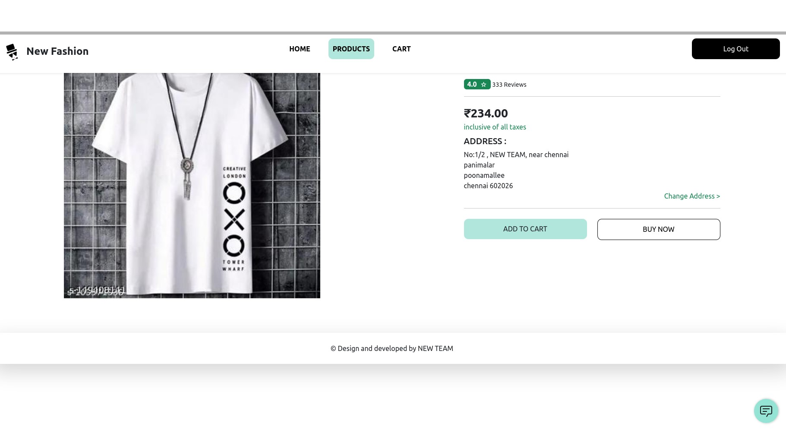

ADMIN PANEL HOME PAGE HTML

|  |
| --- |
| <div class="container-fluid h-100"> |
| <div class="row h-100 flex-nowrap position-fixed w-100"> |
| <!-- nav bar --> |
| <div class="col-8 col-md-3 col-lg-2 h-100 nav-con" |
| *ngIf="showNav"> |
| <!-- logo image --> |
| <div class="fw-bold text-dark">  <img class="logo-img" src="/assets/logo.png" /> |
| <span class="d-none d-md-inline">New Fashion</span> |
| <div class="d-md-none"> |
| <span>New Fashion</span> |

|  |
| --- |
| </div> |
| </div> |
| <hr> |
| <nav class="nav-bar">  <ul> |
| <li class="mt-2"><a class="py-3 ps-3 nav-link" |
| routerLinkActive="active" routerLink="/admin" |
|  |
| [routerLinkActiveOptions]="{exact:true}">Products |
| List</a></li> |
| <li class="mt-2"><a class="py-3 ps-3 nav-link"  routerLinkActive="active" routerLink="orders" |
|  |
| [routerLinkActiveOptions]="{exact:true}">Orders |
| List</a></li> |
| <li class="mt-2"><a class="py-3 ps-3 nav-link" |
| routerLinkActive="active" routerLink="category" |
| [routerLinkActiveOptions]="{exact:true}">Category |
| List</a></li> |
| <li class="mt-2"><a class="py-3 ps-3 nav-link" |
| routerLinkActive="active" routerLink="add-product" |
| [routerLinkActiveOptions]="{exact:true}">Add |
| Products</a></li> |
| <li class="mt-2 position-fixed bottom-0 mb-4"><a  class="py-3 px-3 px-md-5 nav-link border border-dark" |
| (click)="logout()"><span |
| class="material-symbols-outlined" |
| style="vertical-align: bottom;"> |
| logout |
| </span> <span class="ms-3">Log |
| Out</span></a></li>  </ul> |
| </nav> |
| </div> |
| <!-- top nav content --> |
| <div class="col-12 col-md-9 col-lg-10 p-0 flex-fill |
| overflow-scroll"> |
| <div class="d-flex top-nav px-3 py-3 w-100  justify-content-between"> |
| <div class="material-symbols-outlined cursor-pointer" |
| (click)="toggleNav()"> |
| menu |
| </div> |
| <div> |
| profile |
| </div>  </div> |
| <!-- main content of route --> |
| <main class="p-1 p-md-3"> |
| <router-outlet></router-outlet> |
| </main> |
| </div> |
| </div>  </div> |

CSS

|  |
| --- |
| .nav-con, .top-nav { |
| background-color: var(--primary-color); |
| } |
| a { |
| text-decoration: none; color: black; |
| } |
| .nav-bar > ul { |
| list-style: none; |
| font-weight: bold; |
| } |
| .nav-bar a { |
| border-radius: 10px; |
| } |
|  |
| .top-nav { |
| position: fixed; |
| top: 0;  } |
| main { |
| margin-top: 60px; |
| } |
| .nav-link:hover, |
| .nav-link.active { |
| background-color: white;  } |
|  |
| .logo-img { |
| width: 4rem; |
| height: 4rem; |
| } |
|  |

OUTPUT SCREEN:

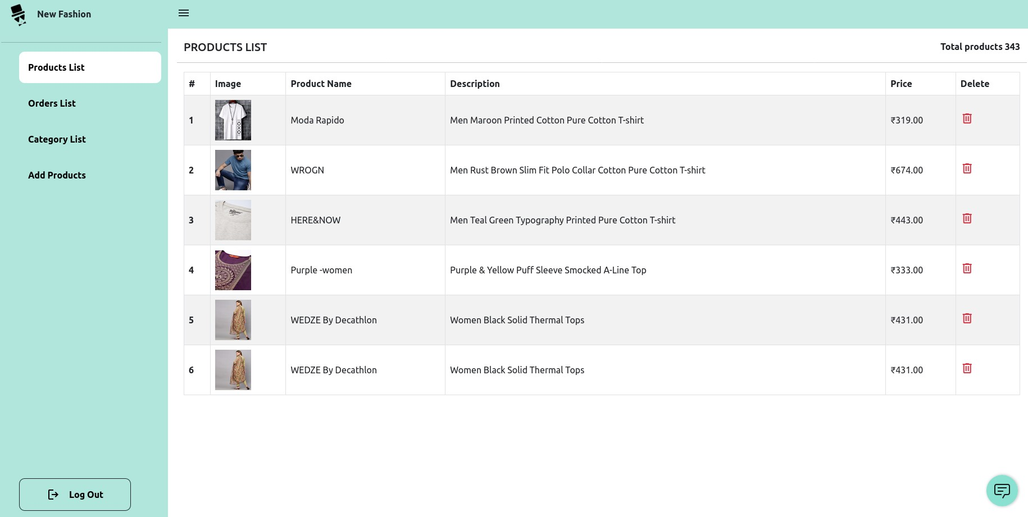

ORDER PAGE HTML PAGE:

|  |
| --- |
| <section class="container">  <div class="row"> |
| <div class="d-flex justify-content-between"> |
| <h5>ORDERS LIST</h5> |
| <p class="fw-bold">Total orders {{'343'}}</p> |
| </div> |
| <hr> |
| <!-- orders list -->  <div class="col-12"> |
| <div class="table-responsive"> |
| <table class="table table-striped table-hover |
| table-bordered"> |
| <thead> |
| <tr> |
| <th scope="col">#</th>  <th scope="col">User Name</th> |
| <th scope="col">Product Name</th> |
| <th scope="col">Product Price</th> |
| <th scope="col">Order Date</th> |
| </tr> |
| </thead> |
| <tbody class="align-middle"> |
| <tr *ngFor="let t of [1,1,1,1,1,1,1,1,1], index  as i"> |
| <th scope="row">{{i+1}}</th> |
| <td>Devendran</td> |
| <td>Dress</td> |
| <td>{{'322' | currency: 'INR'}}</td> |
| <td>{{'27-08-2022'}}</td> |
| </tr>  </tbody> |
| </table> |
| </div> |
| </div> |
| </div> |
| </section> |

OUTPUT SCREEN:

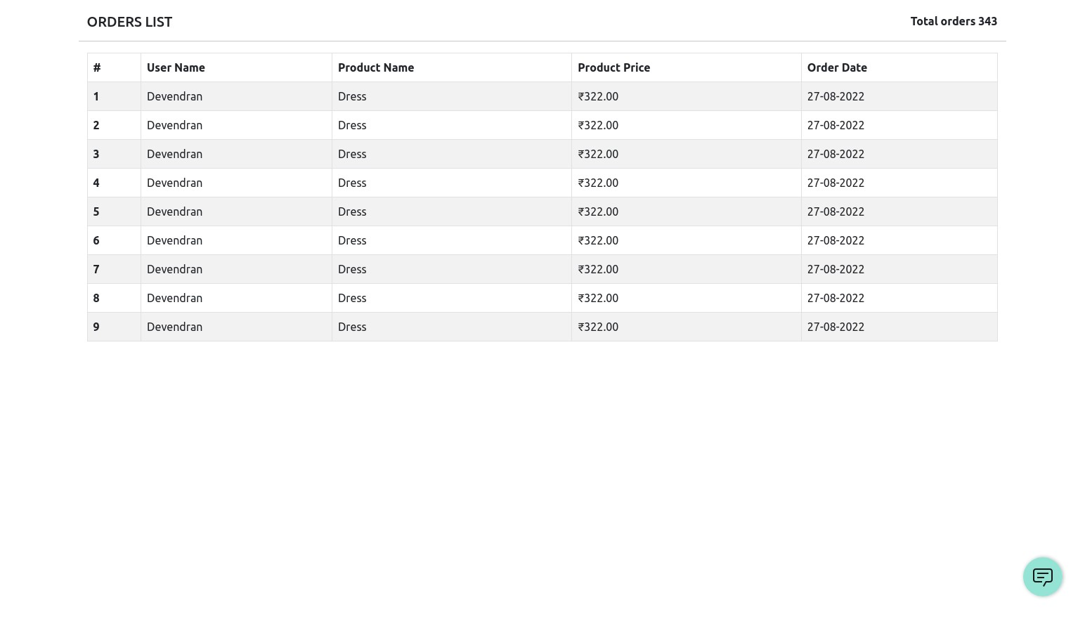

CATEGORY PAGE HTML

|  |
| --- |
| <section class="container"> |
| <div class="row"> |
| <div class="d-flex justify-content-between mb-3"> |
| <h5>CATEGORY LIST</h5>  <div class="position-relative"> |
| <button class="primary-btn" |
| (click)="toggleAddCategory()">Add |

|  |
| --- |
| Category</button> |
| <span class="position-absolute add-category-card shadow |
| border text-success" |
| *ngIf="successMessage !==  ''">{{successMessage}}</span> |
| <!-- add category --> |
| <form class="position-absolute add-category-card shadow |
| border" *ngIf="showAddCategory" |
| [formGroup]="addCategory" |
| (ngSubmit)="createCategory()"> |
| <input type="text" placeholder="New Category Name"  class="form-input" formControlName="category"> |
| <div class="text-center"> |
| <button class="secondary-btn" type="submit" |
| style="background-color: var(--primary-color);" |
|  |
| [disabled]="this.addCategory.invalid">Create</button> |
| </div>  </form> |
| </div> |
| </div> |
| <hr> |
| <!-- orders list --> |
| <div *ngIf="categoryList.length === 0"> |
| Loading  <div class="spinner-border text-dark ms-3" |
| style="vertical-align: bottom;" role="status"> |
| <span class="visually-hidden">Loading...</span> |
| </div> |
| </div> |
| <div class="col-12" *ngIf="categoryList.length > 0"> |
| <div class="table-responsive">  <!-- table --> |
| <table class="table table-striped table-hover |
| table-bordered w-auto"> |
| <thead> |
| <tr> |
| <th scope="col">#</th> |
| <th scope="col">Category</th>  <th scope="col">Delete</th> |
| </tr> |
| </thead> |
| <tbody class="align-middle"> |
| <tr *ngFor="let t of categoryList, index as i"> |
| <th scope="row">{{i+1}}</th> |
| <td>{{t.CATEGORY_NAME}}</td> |
| <td>  <span class="material-symbols-outlined |
| cursor-pointer text-danger" |
| (click)="deleteCategory(t.ID)"> |
| delete |
| </span> |
| </td> |
| </tr> |
| </tbody> |
| </table> |
| </div> |
| </div> |
| </div> |
| </section> |

OUTPUT SCREEN:

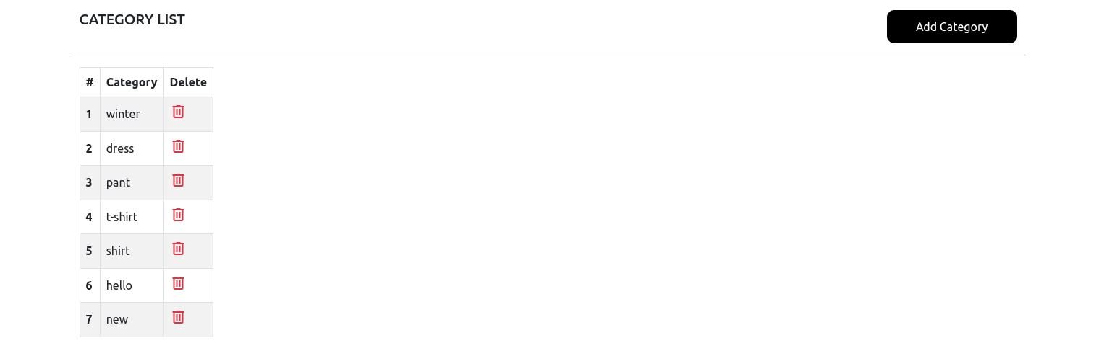

ADD PRODUCT SCREEN HTML:

|  |
| --- |
| <section class="container"> |
| <div class="row">  <h4>Add new product</h4> |
| <hr> |
| <form class="col-12 col-md-6" [formGroup]="addProductForm" |
| (ngSubmit)="createProduct()"> |
| <input type="text" class="form-input w-100" |
| placeholder="product name" formControlName="product_name"> |
| <textarea type="text" class="form-input w-100"  placeholder="Description" formControlName="description"></textarea> |
| <input type="number" class="form-input w-100" |
| placeholder="Price" min="1" formControlName="price"> |
| <input type="number" class="form-input w-100" |
| placeholder="Stock" min="1" formControlName="stock"> |
| <select name="category" class="form-input w-100 py-3" |
| formControlName="category">  <option value="">Select Category</option> |
| <option [value]="c.ID" *ngFor="let c of |
| categoryList">{{c.CATEGORY_NAME}}</option> |
| </select> |
| <div> |
| <button class="primary-btn" type="submit">Add |
| Product</button>  </div> |
| </form> |
| <!-- <div class="col-12 col-md-6 text-center"> |
| <p>select product image</p> |
| <img src="/assets/products/4.jpg" alt="Product image" |
| class="product-img"> |
| </div> -->  </div> |
| </section> |

|  |
| --- |
| import ibm_db |
|  |
| conn = None |

OUTPUT SCREEN:

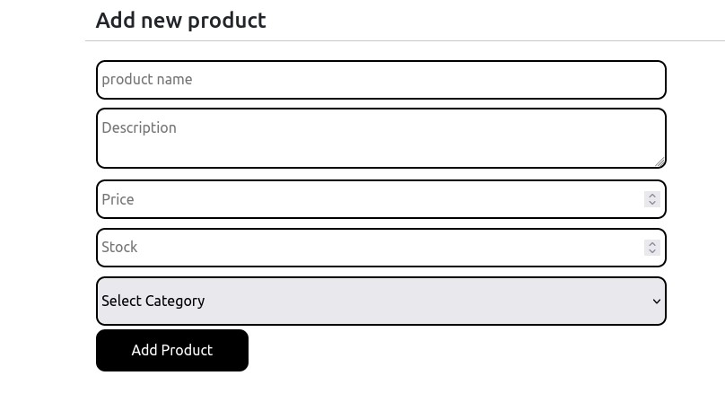

DB CONNECTION

|  |
| --- |
|  |
| def get_db(): |
| global conn |
| print(conn) if conn == None: |
| conn = |
| ibm_db.connect("DATABASE=bludb;HOSTNAME=9938aec0-8105-433e-8bf9-0fbb7e4 |
| 83086.c1ogj3sd0tgtu0lqde00.databases.appdomain.cloud;PORT=32459;SECURIT |
| Y=SSL;SSLServerCertificate=DigiCertGlobalRootCA.crt;UID=yvp21124;PWD=jN |
| DAkHSrZNopa2oe",'','') |
| return conn |

TOKEN VERIFY

|  |
| --- |
|  |
| import jwt |
| from . import validation_error |
|  |
| def check_auth(request): |
| token = request.headers['Authorization'] if (not token): |
| return validation_error.throw_validation("Please login",401) |
| decoded = jwt.decode(token,"secret",algorithms=["HS256"]) |
| return decoded['id'] |